Place diagnostic
Making your own Transformation Route Map

Table of Contents
1. Introduction 2
Strategic approaches to renewal 2
Fact finding for your Route Map 2
A. Insight to Restructuring 4
Insight to Restructuring: total score _______ 6
Useful additional resources about restructuring: 6
B. Insight to Repositioning 7
Insight to Repositioning: Total score _______ 9
Useful additional resources about repositioning: 9
C. Insight to Rebranding 11
Insight to Rebranding: total score _______ 12
Useful additional resources for rebranding 13
D. Insight to Reinventing 14
Insight to Reinventing: total score _______ 15
Useful additional resources for reinventing: 16
2. Create your own Route Map 17

- Introduction
This diagnostic is intended to support the development of a local Transformation Route Map that is most suited to your town. Covid-19 has accelerated change on the high street. The steady loss of multiple retailers is set to continue at a faster pace as the pandemic impacts on business turnover, debts grow, footfall in many centres has significantly reduced, and spending has gone elsewhere or changed. You cannot stop this change at a local level, but past experience says that some places will take this as an opportunity to renew their high street whilst others will lack the capacity or foresight to respond or not be organized or focused enough to make an effective response.
So how does your town become somewhere that is ready, able and willing to respond?

Strategic approaches to renewal
Previous work by partners in the Task Force has identified four strategic approaches to renewal (the 4Rs). These provide a structure to help you navigate your route to transformation. The four approaches are:
- Restructuring – putting in place the capacity, leadership and partnerships to deliver change and considering large-scale spatial change that will be needed to transform your town centre
- Repositioning – knowing your town, using relevant data and information to develop a collaborative, inspiring vision that achieves change
- Rebranding – establishing an identity and sense of place that can engender pride, commitment and attachment and making sure you communicate this across the whole community
- Reinventing – activate and animate your town, diversify its attractions. Multifunctional places offer different things that draw in footfall and spend.
You can find more detail on each approach by accessing our eLearning through each link above.

Fact finding for your Route Map
Every town is different – facing their own set of challenges, with varying levels of resource, differing levels of commitment from stakeholders as well as varying capacity for coordination. Reflecting your town’s individual situation, this diagnostic will help you to produce a high-level Route Map that illustrates your own ‘mix’ of the strategic approaches shown above, the timings/dependencies for the approaches as well as the resources that are needed to accomplish them.

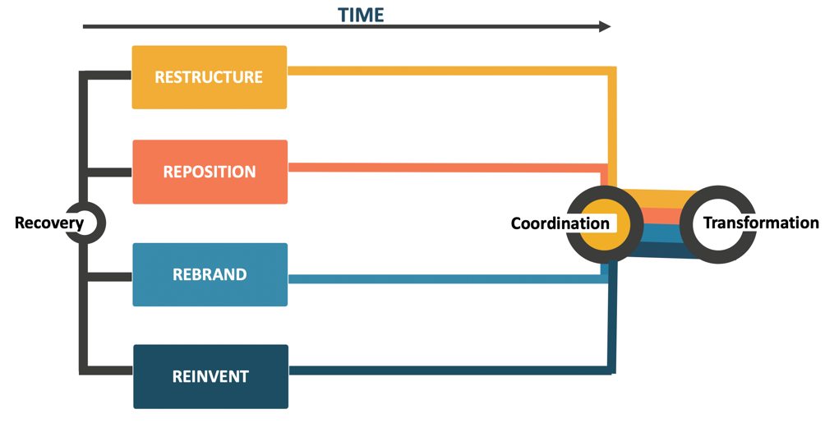
Figure 1: Transformation Route Map

The Transformation Route Map figure above is a way of graphically representing the mix of 4Rs strategies that is relevant to your place. When you have considered this, you can adjust the boxes in your Route Map to show this unique mix.
Although each of the four steps is important, as every place is different, some may be more significant for your location than others now or require greater effort to progress.
As a starting point to check which of the 4R strategies are most significant to your place, take time to answer the questions in the following sections.

Insight to Restructuring
The webinar on restructuring that supported the development of the Route Map covered:
- The role of effective partnerships with businesses and the wider community as the only way to build capacity for change
- The importance of place management and coordination in the recovery and transformation process
- Reflecting on the suitability of existing partnerships and governance arrangements in their location
The webinar provided examples of how this has happened in Worcester and Altrincham and heard about the importance of working with communities and other stakeholders such as LEPs, BIDs, and other tiers of local government.
You can access a recording of the Restructuring webinar.
Answering a number of questions will help you understand where you are now.

A1 List all organisations that are actively managing change in your town
(e.g. local government tiers, place management partnerships, civic or community groups, business groups, etc.)
1.
2.
3.
4.
5.
6.
7.
8.
To score 1 point you must name 3 organizations. After the first 3, each subsequent organization scores 1 point.

A2 Is there a structure(s) in your town currently coordinating everyday activity across the groups named in A1?
Yes
No
Score 1 point if you have answered ‘Yes’, 0 points if you have answered ‘No’.

A3 Is there a structure(s) in your town forward planning and managing transformation?
Yes
No
Score 1 point if you have answered ‘Yes’, 0 points if you have answered ‘No’.

A4 Do the groups in A2 and A3 relate to each other?
Yes
No
Score 1 point if you have answered ‘Yes’, 0 points if you have answered ‘No’.

A5 Are community members involved in everyday management?
Yes
No
Score 1 point if you have answered ‘Yes’, 0 points if you have answered ‘No’.

A6 Are community members involved in transformation?
Yes
No
Score 1 point if you have answered ‘Yes’, 0 points if you have answered ‘No’.

A7 Are businesses involved in everyday management?
Yes
No
Score 1 point if you have answered ‘Yes’, 0 points if you have answered ‘No’.

A8 Are businesses involved in transformation?
Yes
No
Score 1 point if you have answered ‘Yes’, 0 points if you have answered ‘No’.

A9 Is your town prepared/preparing for the scale of spatial change required to be vital and viable in the future
Yes
No
Score 1 point if you have answered ‘Yes’, 0 points if you have answered ‘No’.

A10 Follow this link to complete a diagnostic on capacity and structures for managing change and tick the name identified in the answer
Apathetic
Paternal
Grassroots
Plural
Score 1 point if you have answered ‘Plural’, 0 points if you have answered any of the rest.

Insight to Restructuring: total score _______
A high score in this is a sign you are well prepared for restructuring. However, if your score is lower than five, then, you will need to work on your partnerships and leadership culture and/or if you have spatial challenges to overcome (like your town centre is in the wrong place!) to address these issues as a priority. Without the capacity and structures for action and/or transformation any effort and investment will be ‘piecemeal’ and not result in the positive results expected.
By looking at the questions where you have scored 0 points, identify one or two areas of action in relation to Restructuring:
Area(s) of action in relation to Restructuring:

Useful additional resources about restructuring:
Networks and partnerships with Councils One of top 25 priorities that can influence high street vitality and viability. This resource introduces the 'Networks and Partnerships with Councils' priority - why it matters, and what you can do about it. (Institute of Place Management).
High Streets and Town Centres: Adaptive Strategies This comprehensive guidance for high streets and town centres was created as part of the Mayor of London’s Good Growth by Design programme, which aimed to promote and support a framework that would allow high streets and town centres to adapt and diversify. Mayor of London.

Insight to Repositioning
The repositioning webinar that formed part of the Transformation Route Map series covered:
- The myriad forces that are impacting high streets and town centres, including COVID-19
- The importance of data and evidence in making plans and strategies that solve problems
- The importance of the visioning process
- How to develop visions and strategies in a collaborative fashion that develop collective ambition for genuine transformation
We heard a strong message from Bill Grimsey that high streets are losing their purpose and therefore must change, as well as great examples of the development of inclusive visions from Paisley and Shrewsbury. Repositioning means understanding your town now and working collaboratively to make change happen.
You can access a recording of the Repositioning webinar.
A number of questions and actions will help you understand the need in this area

B1 Does your town centre feel safe and welcoming
Yes
No
Score 1 point if you have answered ‘Yes’, 0 points if you have answered ‘No’.

B2 What positive changes do you see locally that are happening in the town or with the local community?
1.
2.
3.
4.
5.
6.
7.
8.
To score 1 point you must name 5 things. After the first 5, each subsequent one scores 1 point.

B3 Wider societal, technological and economic changes are impacting places (COVID, climate change, retail churn and closures, ageing populations, societal behaviour, etc.). What initiatives are happening in the town to respond to or anticipate this change?
1.
2.
3.
4.
5.
6.
7.
8.
To score 1 point you must name 5 things. After the first 5, each subsequent one scores 1 point.

B4 Do stakeholders broadly agree on what the biggest challenges facing the town are?
Yes
No
Score 1 point if you have answered ‘Yes’, 0 points if you have answered ‘No’.

B5 Do stakeholders broadly agree on what the opportunities for the town are?
Yes
No
Score 1 point if you have answered ‘Yes’, 0 points if you have answered ‘No’.

B6 Do you collect footfall data and/or are enrolled on the HSTF manual counting regime?
Yes
No
Score 1 point if you have answered ‘Yes’, 0 points if you have answered ‘No’.

B7 Do you know your town type? (Comparison shopping, speciality, holiday, multifunctional)
Yes
No
Score 1 point if you have answered ‘Yes’, 0 points if you have answered ‘No’.

B8 What data and evidence sources do you regularly use to underpin decision making?
1.
2.
3.
4.
5.
6.
7.
8.
To score 1 point you must name 5 sources. After the first 5, each subsequent one scores 1 point.

B9 Is there a vision for the town?
Yes
No
Score 1 point if you have answered ‘Yes’, 0 points if you have answered ‘No’.

B10 Follow this link to critically evaluate the current vision for your town and then tick below all that apply
I couldn’t find a vision for the town/town centre
A vision has been adopted and there is evident change
The vision is still relevant (or is being updated)
The vision relates to the challenges the town or high street faces
The vision is identifiably about our town/high street, its needs, goals, and priorities, and what it stands for and represents
The first answer scores 0 points. All the rest score 1 point each.

Insight to Repositioning: Total score _______
A high score in this is a sign you are well prepared for repositioning. However, if your score is lower than five, you will need to work on your evidence base and develop a vision that captures aspirations and inspires people to be part of the transformation journey, then you need to work on repositioning your town through reinventing and rebranding.
By looking at the questions where you have scored 0 points, identify one or two areas of action in relation to Restructuring:
Area(s) of action in relation to Repositioning:

Useful additional resources about repositioning:
A Vision for High Street Regeneration This report provides guidance around why a vision is needed, what a vision will do, and how a vision can be effectively implemented to create diverse, sustainable, and thriving places. It provides a 22-point ‘High Street Manifesto for Change’. (Threesixty Architecture et al)
Build Back Better: Grimsey Review COVID-19 Supplement A comprehensive exploration of how town centres and high streets can transform in order to thrive post-Covid19. The report stresses the importance of local communities and leadership, community hubs, attractive and accessible public realm, and multi-functionality. (Bill Grimsey et al)
Repositioning the high street: evidence and reflection from the UK Repositioning is the regeneration strategy discussed in this paper. It involves understanding data and trends to build collective visions and forward-looking strategies to meet catchment needs. (Ntounis N, Millington S, Institute of Place Management)
Footfall signatures and volumes: Towards a classification of UK centres Definitions and classifications of town centres currently adopted by UK planners and policy makers are outdated, because of their focus on retail occupancy. Instead a more dynamic definition and classification of centres, based on their activity volumes and patterns, can alter and improve the way in which they are developed and managed (Mumford et al.).
Guidance for manual footfall counting regime This resource shows you how to engage in a manual footfall counting regime, which, if you complete will give you access to the High Streets Task Force Standard Dashboard. The manual footfall counting regime is for local authorities, and other place management organisations, like BIDs or community groups, who do not have automatic footfall counting technology, but who want to use footfall as an indicator of the health and attractiveness of their town centre (High Streets Task Force).

Insight to Rebranding
The Transformation Route Map rebranding webinar covered:
- The importance of excellent communication between stakeholders
- The concept of placefulness as way of identifying what is special and valued about your place
- How marketing and branding principles can be used to build loyalty and commitment to your place
The webinar heard about how perceptions of your town are now increasingly being formed by social media, and the opportunities to influence that. This is already underway in Putney from where we heard an example. Dr Steve Millington discussed the sense of place as against clone towns and the need to develop a distinct identity or placefulness and necessity of involving the community in this. We heard of how this was being done in East Lindsey’s towns.
Access a recording of the Rebranding webinar.
Again, we have a number of questions to address in this area.

C1 Do stakeholders broadly agree on what the unique aspects of the town are?
Yes
No
Score 1 point if you have answered ‘Yes’, 0 points if you have answered ‘No’.

C2 Do the unique aspects of the town feature in promotions and communications?
Yes
No
Score 1 point if you have answered ‘Yes’, 0 points if you have answered ‘No’.

C3 What is the reputation of your town at a regional or national level?
Poor
Indeterminate
Good
Score 1 point if you have answered ‘Good’, 0 points if you have answered any of the rest.

C4 Does the local paper or other local media support efforts to change/improve the town
Yes
No
Score 1 point if you have answered ‘Yes’, 0 points if you have answered ‘No’.

C5 Do local people talk your town down?
Yes
No
Score 1 point if you have answered ‘No’, 0 points if you have answered ‘Yes’.

C6 Are local people aware and updated on what is happening in town and what future plans are?
Yes
No
Score 1 point if you have answered ‘Yes’, 0 points if you have answered ‘No’.

C7 Is there evidence of informal communication and networking?
Yes
No
Score 1 point if you have answered ‘Yes’, 0 points if you have answered ‘No’.

C8 Is your location outward looking and inclusive?
Yes
No
Score 1 point if you have answered ‘Yes’, 0 points if you have answered ‘No’.

C9 Does your town appear looked after?
Yes
No
Score 1 point if you have answered ‘Yes’, 0 points if you have answered ‘No’.

C10 Follow this link to conduct a place perceptions snapshot and post comments on results here
We have a significant online presence and reviews on balance are positive
We have a significant online presence and reviews on balance are negative
We have very little online presence
Score 1 point for the first answer. Score 0 points for the other two.

Insight to Rebranding: total score _______
A high score in this is a sign you are well prepared for rebranding. However, if your score is lower than five, then communication and perceptions are poor, and you may need a rebranding strategy. This includes stakeholder communications as well as traditional marketing activities.
By looking at the questions where you have scored 0 points, identify one or two areas of action in relation to Rebranding:
Area(s) of action in relation to Rebranding:

Useful additional resources for rebranding
Re-branding the high street: the place branding process and reflections from three UK towns Rebranding is the regeneration strategy discussed in this paper. It involves communicating clear and consistent messages about a place’s identity to the people who live, work, and visit that place. (Ntounis N, Kavaratzis M, Institute of Place Management)
Place-based storytelling This report builds on research into towns that have significantly transformed their fortunes, in part by creating a clear place narrative. Find out how to (co)create effective stories to improve community wellbeing, local engagement, and attract people back into high streets and town centres, post-crisis. (Carnegie UK Trust)

Insight to Reinventing
The reinventing webinar covered:
- Defining the end-goal…what do you want to achieve in your high street/town centre?
- The role of the town centre/high street in wider economic, environmental and societal transformation
It explored the challenges of doing things differently looking at what is happening to coastal towns, localism, issues of ownership, the importance of social anchor institutions as ‘sticky capital’, and creating resilience. We also had insight from Rachel Fisher, Deputy Director of Regeneration and Investment for MHCLG and BEIS on the government support for town centres.
You can access the Reinventing webinar.
Reinventing is both long and short term. We are seeing lots of reinventing now so that town centres can adjust to trade during COVID, some are local responses, some are national requirements.
Again, we have a series of questions that will provide insight to your own place.

D1 Do you have partnerships but little or no action?
Yes
No
No partnerships
Score 1 point if you have answered ‘No’, 0 points if you have answered ‘’.’Yes’ or ‘No partnerships’

D2 Do you have plans and visions, but little or no investment?
Yes
No
No plans or visions
Score 1 point if you have answered ‘No’, 0 points if you have answered ‘Yes’ or ‘No plans or visions’.

D3 Do you have many buildings and developments that are not occupied?
Yes
No
Score 1 point if you have answered ‘No’, 0 points if you have answered ‘Yes’.

D4 In normal times, do you feel there is a lack of events, markets or festivals?
Yes
No
Score 1 point if you have answered ‘No’, 0 points if you have answered ‘Yes’.

D5 Are there significant numbers of businesses not reopening after COVID?
Yes
No
Score 1 point if you have answered ‘ ‘No’, 0 points if you have answered ‘Yes’.

D6 Is there normally activity in the town centre after 6pm?
Yes
No
Score 1 point if you have answered ‘Yes’, 0 points if you have answered ‘No’.

D7 Is the town very quiet every Sunday?
Yes
No
Score 1 point if you have answered ‘No’, 0 points if you have answered ’Yes’

D8 Is there recent or current development happening in the town centre?
Yes
No
Score 1 point if you have answered ‘Yes’, 0 points if you have answered ‘No’.

D9 Are new businesses moving into town?
Yes
No
Score 1 point if you have answered ‘Yes’, 0 points if you have answered ‘No’.

D10 Are the temporary changes being made for COVID of a decent quality? Follow this link to see what is happening elsewhere and assess against your town
Yes
No
Score 1 point if you have answered ‘Yes’, 0 points if you have answered ‘No’.

Insight to Reinventing: total score _______
A high score in this is a sign you are well prepared for reinventing. However, if your score is lower than five, you need a strategy of reinventing to get transformation moving. This might mean activating space and buildings, rather than creating new space and buildings.
By looking at the questions where you have scored 0 points, identify one or two areas of action in relation to Reinventing:
Area(s) of action in relation to Reinventing:

Useful additional resources for reinventing:
Reinventing town centres: a call for action In an attempt to halt any further decline of the UK’s town centres and High Streets, as could well happen without recovery post-Covid-19, this article suggests a radical approach, rather than business as usual, and proposes 5 steps to rapid recovery, which may be particularly helpful to mid-sized towns. (Falk N.)
How to reinvent the high street: evidence from HSUK2020 Reinventing is the regeneration strategy discussed in this paper. It involves understanding how to maintain a centre’s relevance for the catchment, as well as adapting to meet changing needs of current and future users. (Theodoridis C et al Institute of Place Management)
Own the future: a guide for new local economies This report provides a guide for people willing to rebuild local economies whether that be politicians, officers, community activists, interested citizens or all levels of UK local government. The document outlines how to start taking actions towards recovery and development of local economies and communities through collaborative approaches. (Centre for Local Economic Strategies CLES).

Create your own Route Map
The assessments are designed for you to judge priorities and begin to understand the scale of change required and the timescales and resources associated with that. How did you do? Did this identify one or more areas where action is needed? Do all four need addressing? Based on the Task Force knowledge of town centres, this would not be an unusual result.
You have to decide what you need to do first. You might want to focus on the approach which you have the most problems with now or where you can see an early win.
To help you think more about the challenge, and to explain to others, you can use our downloadable PowerPoint version of the Route Map to change the order of the process by moving the strategies to the left or right, the duration of each approach, by altering the length of the box, and you can represent how much investment they need by changing the size of the box. Here you can also include the areas of action identify for each, and these areas of action might help you decide priority and resources needed.
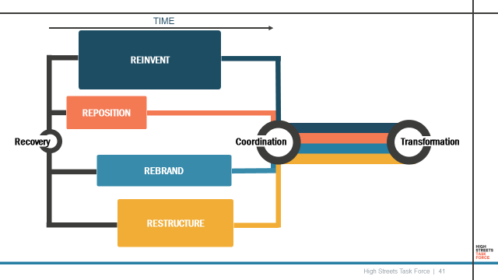
The first step in this process is to work with others. You could share this diagnostic and compare results and then you need to consider the structures that will allow you to engage with other local groups. We saw from the example of Altrincham that there are a range of models, partnerships and ways to govern the collective of people that care about your place. From Town Centre Partnerships, to landlord registers and forums, retail forums, communications programmes, and groups for neighbourhood planning, community space, and development. Establishing the structures that will most effectively enable you to harness local groups is key to capitalising on capacity. This will also enable you to hear ideas, concerns and different viewpoints on what others would like their town to be like in the future.

